DESIGN AND ANALYSIS OF ALGORITHMS
ASSIGNMENT 2 – CO2
Brute-Force and Exhaustive-Search Techniques

Submitted by
DEEPAK S
Register Number: 192511124
Department of Computer Science and Engineering

Table of Contents
- Assignment overview
- Q1 – Sorting under different data conditions
- Q2 – Sequential search
- Q3 – Brute-force string matching
- Q4 – Closest pair
- Q5 – Convex hull
- Q6 – Exhaustive search
- Q7 – Day-4 design challenge
- Overall conclusion
- Appendix – Reproducibility

Assignment Overview
This report addresses the seven questions in the supplied Assignment 2 – CO2 brief. The assignment evaluates Predict → Design → Implement → Measure → Analyse → Evaluate → Diagnose → Redesign → Validate. C programs are provided separately in the GitHub package.
Primary evidence is operation counts (comparisons, moves, pairs, orientation tests, subsets and probes). Execution time is supplementary because it varies by machine and compiler.
Assumptions: datasets are deliberately small and reproducible; counts refer to the supplied program logic. For large-size growth claims, mathematical formulas are used where direct execution would be unnecessary.

Q1 – Sorting Under Different Data Conditions (6 Marks)

Prediction and design
Selection Sort always performs n(n−1)/2 key comparisons, regardless of input order, and performs at most n−1 swaps. Bubble Sort with an early-stop flag can finish after one pass on sorted input; its work increases with inversions. Insertion Sort is adaptive: nearly sorted input requires few shifts, while reverse/disordered input can require quadratic shifts.
Dataset | Input values | Purpose
Random | 8, 3, 7, 1, 9, 2, 6, 4, 5 | Contrasting unsorted order
Nearly sorted | 1, 2, 3, 5, 4, 6, 7, 8, 9 | Only one local inversion
Sorted edge case | 1, 2, 3, 4, 5, 6, 7, 8, 9 | Best case for adaptive algorithms

Algorithm design
Selection: repeatedly select the minimum remaining value. Bubble: swap adjacent inversions and stop when a pass makes no swap. Insertion: shift larger prefix elements and insert the current key.

Experimental evidence
Dataset | Algorithm | Comparisons | Moves / writes
Random | Selection | 36 | 18
Random | Bubble | 30 | 60
Random | Insertion | 26 | 36
Nearly sorted | Selection | 36 | 3
Nearly sorted | Bubble | 15 | 3
Nearly sorted | Insertion | 9 | 17
Sorted | Selection | 36 | 0
Sorted | Bubble | 8 | 0
Sorted | Insertion | 8 | 16
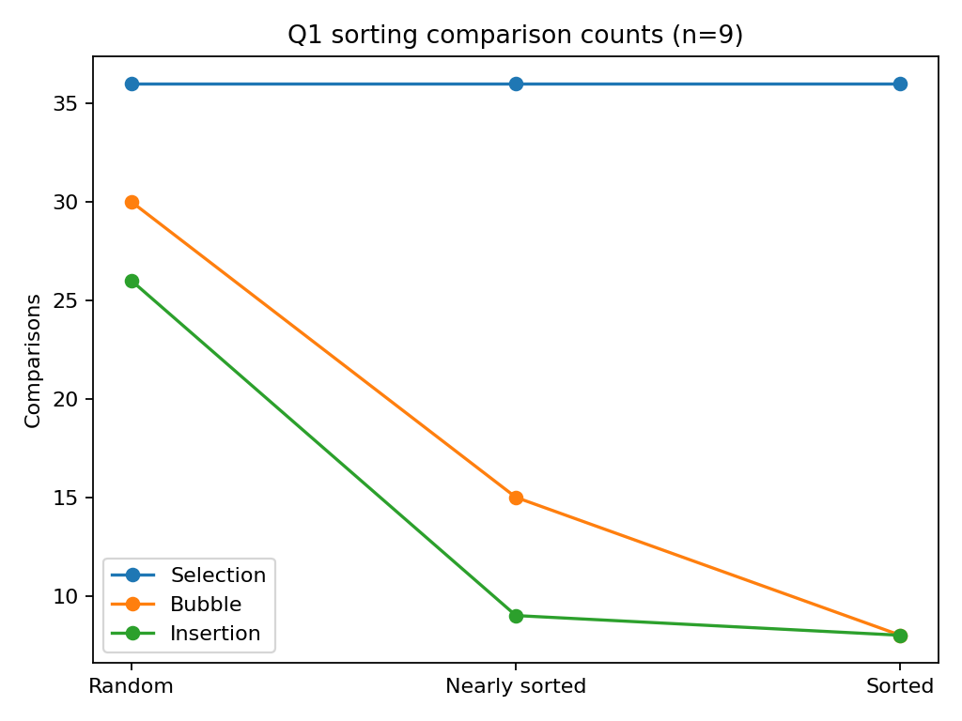
The observations support the prediction: Selection Sort's comparisons remain fixed at 36 for n=9. Bubble and Insertion reduce comparisons substantially on ordered data. On the random dataset, Bubble uses 30 comparisons and 60 moves, while Insertion uses 26 comparisons and 36 moves. Insertion's moves include key placement and shifts, so sorted input still records key-handling writes.

Complexity and recommendation
Selection Sort: Θ(n²) comparisons and O(n) swaps. Bubble Sort: O(n²) average/worst, O(n) best with early stopping. Insertion Sort: O(n²) average/worst and O(n) best. Since approximately 95% of existing orders are already correctly ordered and only small batches arrive, recommend Insertion Sort for each small update batch. It exploits existing order and avoids sorting the entire list from scratch. For very large or frequent updates, a maintained ordered data structure may be preferable.

Q2 – When Is Sequential Search Appropriate? (4 Marks)
Sequential Search scans records from the beginning until the Tool ID is found or the list ends. It is simple, requires no preprocessing, and works well for small, frequently changing lists.
Search case | List size | Target position | Comparisons
Successful | 5 | First | 1
Successful | 5 | Middle | 3
Successful | 5 | Last | 5
Unsuccessful | 5 | Absent | 5
Unsuccessful | 20 | Absent | 20
Unsuccessful | 100 | Absent | 100
Unsuccessful | 1000 | Absent | 1000
Best case is O(1); average and worst cases are O(n). For uniformly likely successful searches, expected comparisons are approximately (n+1)/2. For an unsuccessful search, exactly n comparisons are needed.
Sequential search is reasonable for a small temporary list, low request rate, and frequent insertions/deletions where maintaining an index adds complexity. Stop recommending it when the active list becomes large or lookup requests are frequent. Expansion to 20 facilities increases record count and request volume; a shared indexed lookup is then justified.

Q3 – Brute-Force String Matching (6 Marks)
The algorithm aligns the pattern at every possible text position and compares characters from left to right until a mismatch or full match.
Test | Text / pattern design | Expected behaviour | Measured comparisons
1 – low work | security alert: login failed / alert | Short pattern match after early mismatches | 13
2 – repeated prefix | aaaaaaaaaaaaaaaaab / aaaaab | Many alignments share a long prefix | 78
3 – periodic | ababababababababac / ababac | Overlapping periodic prefixes create partial matches | 30
Worst-case time is O((n−m+1)m), commonly written O(nm); auxiliary space is O(1). The second test is expensive because each alignment matches several repeated 'a' characters before failing. Input length alone does not describe the work: pattern length and repeated-prefix structure also matter.
The implementation counts every character equality test, including the final mismatch at each alignment. Counts are obtained by executing the included C program.

Q4 – Closest Pair and the Cost of Examining Every Possibility (6 Marks)
For each point i, compare it with every later point j=i+1,...,n−1. This examines each unordered pair once and excludes self-pairs.
There are n choices for the first endpoint, n−1 for the second, but each unordered pair is counted twice in n(n−1). Therefore the number of unique pairs is C(n,2)=n(n−1)/2.
n drones | Unique pairs | Distance calculations
4 | 6 | 6
6 | 15 | 15
8 | 28 | 28
100 (formula) | 4,950 | 4,950
1,000 (formula) | 499,500 | 499,500
Each distance uses √((xi−xj)²+(yi−yj)²). Time is Θ(n²), auxiliary space O(1). Define an acceptable response time as 1 second on the target deployment machine; the practical boundary must be measured on that machine, not inferred from this small demonstration. The inefficiency comes from checking every pair. A redesign should exploit spatial proximity or spatial ordering to avoid most pair-distance calculations.

Q5 – Derive a Convex Hull Algorithm from a Geometric Principle (7 Marks)
For candidate points A and B, compute signed cross product z=(Bx−Ax)(Py−Ay)−(By−Ay)(Px−Ax) for every other point P. Positive means one side; negative means the other; zero means collinear.
If at least one point lies on each strict side, AB cannot be a supporting hull line. If all points lie on one side or on the line, AB is a supporting-line candidate. Enumerating every pair and checking all other points requires O(n³) orientation tests.

Pseudocode
For every pair of distinct points A,B, evaluate the cross product (B-A) x (P-A) for every other point P. Track whether points occur on the positive and negative sides. If both sides occur, AB is not a supporting line. Otherwise AB is a supporting-line candidate. Remove duplicate edges; order accepted hull vertices around the centroid for a polygon display. Collinear boundary points need a consistent policy.
The included test contains square corners and interior points. A second challenge dataset is a set of points on a circle: every point is a hull vertex and many candidate edges will be accepted. Collinear boundary points require care: a line can contain multiple stations, so an implementation must retain extreme endpoints or order collinear boundary points consistently.
Correctness reasoning: a convex-hull edge lies on a supporting line with the entire point set in one closed half-plane. If points occur on both strict sides, the segment is internal and cannot be a hull edge. Accepted candidates must be deduplicated and ordered to construct the polygon.
Limitation: the supplied prototype identifies supporting-line candidates, not a fully ordered polygon for all degenerate point sets. This is noted rather than claiming a complete robust geometric library implementation.

Q6 – Exhaustive Search and Combinatorial Growth (8 Marks)
Represent a package combination as an n-bit mask. Bit i is 1 when package i is selected. There are two choices per package (include/exclude), so the solution space contains 2ⁿ subsets.
Package | Weight | Humanitarian value
P1 | 2 | 12
P2 | 1 | 10
P3 | 3 | 20
P4 | 2 | 15
Payload capacity = 5. The C program enumerates all 16 masks, totals weight and value, rejects overweight subsets, and retains the feasible subset with maximum value.
For the supplied instance, the best feasible combination is P1 + P2 + P4: total weight 5 and value 37. The empty set is also considered. This small case can be independently checked by listing all 16 combinations.
Packages n | Candidate subsets 2ⁿ
4 | 16
10 | 1,024
15 | 32,768
20 | 1,048,576
25 | 33,554,432
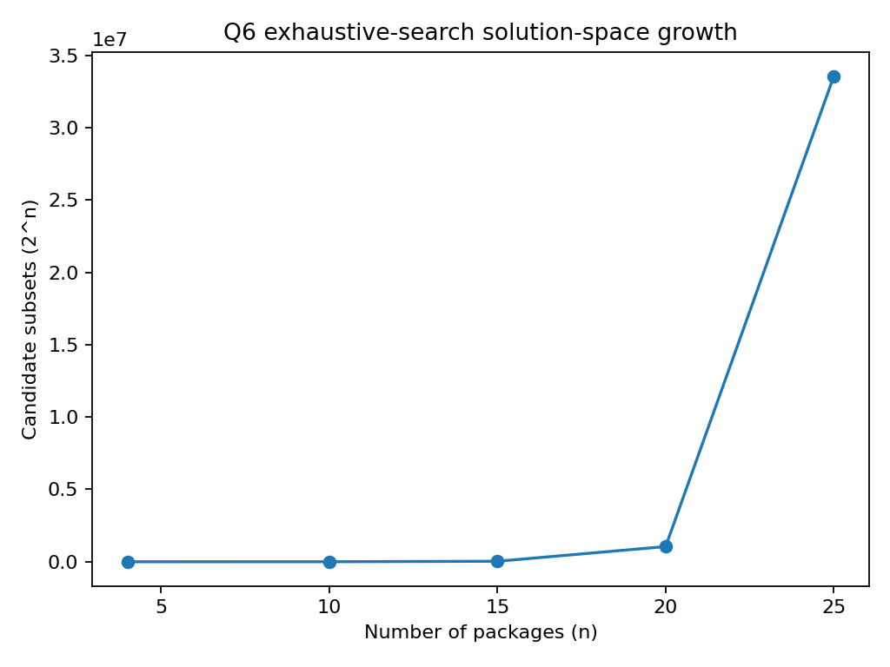
Time is O(n·2ⁿ) for the straightforward implementation that sums each subset from its bits; auxiliary space is O(1) beyond the input and current best subset. Adding five packages multiplies candidates by 32.
Deployment decision: set a response-time budget of 1 second. On the target machine, time the compiled program before deployment; operation counts show n=20 already means over one million subsets and n=25 exceeds 33 million. A conservative initial boundary is n≤20 until machine-specific benchmarking demonstrates a larger safe limit.

Q7 – Day-4 Design Challenge: Diagnose, Redesign and Validate (13 Marks)

Selected limitation: repeated sequential Tool-ID lookup
A sequential scan performs up to n record comparisons for each lookup. With r requests, worst-case work is O(rn). At n=1,000 and r=10,000 absent lookups, the scan can perform 10,000,000 record checks.

A. Diagnose the bottleneck (2 marks)
The dominant operation is the Tool-ID equality check. Its worst-case count grows linearly with active records per request; absent IDs always scan the full list. The same records are scanned repeatedly across requests.

B. Design objective (2 marks)
Reduce expected lookup work from O(n) checks per request to approximately O(1) probes at a controlled hash-table load factor, while preserving exact key matching and supporting issue/return updates.

C. Revised strategy (4 marks)
Use a hash table keyed by Tool ID. Compute a hash index and resolve collisions with linear probing. Insert a record when issued and remove/mark it when returned. The prototype uses a fixed-size table; a production version should resize before load becomes high and use tombstones for deletion.
DIAGNOSIS: Repeated sequential lookup checks up to n records per request; many lookups repeat the same scan work.
OBJECTIVE: Reduce expected lookup probes while retaining exact Tool-ID matching.
REDESIGN: Build a hash table from Tool ID to record index using a deterministic hash and linear probing for collisions. Insert/update records as tools are issued; remove or mark records on return. Lookup computes one hash index and probes until key or empty slot.
VALIDATE: Run identical queries through sequential search and hash lookup; compare record checks with hash probes. Trade-offs: extra memory, preprocessing/update logic, collision handling; worst case remains O(n).
The redesign adds memory and index maintenance. Hash collisions can increase probes; worst-case lookup remains O(n). The original sequential scan may still be preferable for tiny lists or one-off queries where building an index costs more than scanning.

D. Prediction before implementation (1 mark)
For the same five-record sample, successful lookups should need fewer record checks on average after indexing, and absent lookups should terminate at an empty slot. The expected improvement measure is record checks/probes, not elapsed time.

E. Implement and validate (2 marks)
Query | Sequential checks | Hash probes
T-101 | 1 | 1
T-184 | 3 | 1
T-220 | 5 | 1
T-999 | 5 | 0
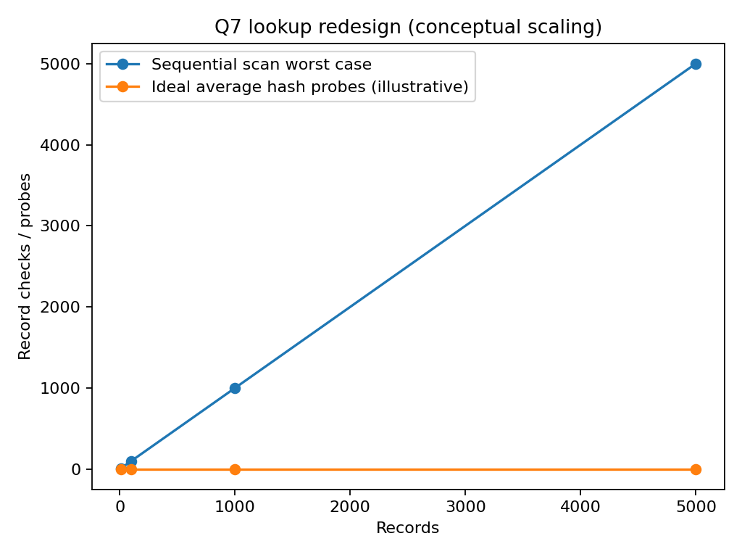
The prototype output confirms fewer probes for middle and last successful queries and immediate termination for the absent query in this collision-free sample. This is a controlled demonstration, not a guarantee that every hash lookup takes one probe.

F. Defend the final design (2 marks)
The prediction is supported for the supplied sample. Benefits grow with repeated lookups and larger record sets. Costs are extra memory, hashing, collision handling, resizing and deletion management. Sequential search remains suitable for tiny, rarely searched, frequently changing lists. For a multi-facility service with high lookup frequency, a maintained hash index is stronger.

Overall Conclusion
The experiments show that algorithm choice depends on data arrangement and operating conditions. Insertion Sort benefits from nearly sorted data; Sequential Search is simple but scales poorly under frequent lookups; brute-force string matching is sensitive to repeated prefixes; closest-pair and convex-hull brute force examine many geometric candidates; exhaustive search grows exponentially. The Day-4 redesign demonstrates how a data structure can reduce repeated work when lookup frequency and dataset size increase.
All operation-count conclusions are tied to the included test cases. Timings are machine-dependent and should be re-measured on the final submission computer.

Appendix – Reproducibility and Submission Checklist
- Compile each C file with GCC; use -lm for Q4 and Q5.
- Run each program and compare output with the included Output_Screenshots and .txt capture.
- Upload the complete CO2_Assignment folder to the individual GitHub repository.
- Keep the report DOCX separate from the GitHub source ZIP.
- Be prepared to explain test-data design, operation counts, mathematical derivations and Q7 trade-offs in the viva.
Source basis: Assignment 2 – CO2 brief supplied by the student. Implementation assumptions and experimental datasets are identified in the report.

